**Damage Assessment**

Damage assessment involves collecting and analyzing spatial data such as satellite imagery and using it to evaluate the extent of the damage and assess the needs of affected areas and people during disasters or crises. Such disasters include floods, cyclones, war bombing. We perform a damage assessment in the wake of disasters to provide fast and timely response that will allow for fast response to those in need.

# **REFERENCE/S**

* In early 2023, we supported war-struck Ukraine in the damage assessment project that set to look within the city of Kramatorsk at the residential buildings that had been affected and the extent of the damage.
  + [Here is a storymap of the results.](https://storymaps.arcgis.com/stories/27e6607a7311403a9eb4ba618e722440?urlKey=crsorg)

**METHODOLOGY**

## **REQUIREMENTS**

* ArcGIS Pro License - request through [ServiceNow Form](https://crsprod.service-now.com/ess_portal/com.glideapp.servicecatalog_cat_item_view.do?v=1&sysparm_id=40ae17fc1be32410c66b8730604bcb8d&sysparm_link_parent=578a0c00db1bd700bb3f400e0b9619d7&sysparm_catalog=e0d08b13c3330100c8b837659bba8fb4&sysparm_catalog_view=catalog_default)
* Geographic Area of Interest in GIS shapefile format. If you don’t have a defined one, we can help you create one using [this tool](https://geojson.io/#map=7.3/0.782/37.002).
* In most cases this work involves acquiring high resolution satellite imagery from a vendor. We are currently looking to partner with one such vendor to allow us to acquire images promptly. 50cm resolution satellite imagery for example costs ~600 € for 50sq km area. In that case we will share a cost of your entire area of interest for imagery.

## **TECHNICAL PROCESS**

Requirements Checklist

* Area of Interest (.shp)
* Satellite Imagery (raster or basemap)

### Analysis process:

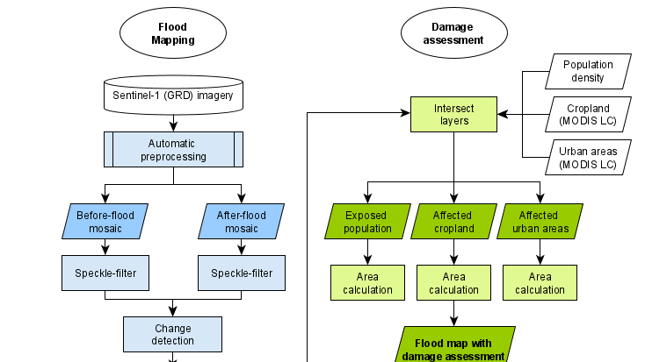

* An illustration of the process for damage assessment of a flooding disaster.

Pre-processing of the satellite imagery like orthorectification and pan-sharpening to get the satellite imagery in the right format for analysis.

We use several unsupervised methods to detect the extent of damage in the area, this is also complemented with a visual analysis of the pre and post disaster images.

We are advancing our techniques to incorporate machine learning models damage assessment using pre and post disaster imagery like outlined in [this paper](https://www.frontiersin.org/articles/10.3389/fenvs.2022.969758/full#B40).

# **PLANNING**

## **TECHNICAL COSTS**

* Storage costs (costs are applied every storage hour)
  + $100 for every 4GB of **building data**(vector layer) stored on ArcGIS Online per month.
  + $100 for every 830GB of **high-resolution imagery** (raster layer) per month.

*For example, since Benin is 114,763 km2their building data is around 2.7 GB, which consumes 658.44 credits per month amounting to $65.84 cost per storage month.*

* Satellite imagery cost
  + Depends on availability and resolution. As mentioned, 50cm resolution for 50sq km costs ~600€. To know more check out this [one-pager for Satellite Imagery](https://crsorg.sharepoint.com/sites/Knowledge-and-Innovation/SitePages/Satellite-Imagery.aspx).
* Staff Support
  + Data and Geospatial Analytics Team provides **Spatial Analytics** support with **no charge back** for work < 80 hours. Fill out an [**ICT4D Services Support Request Form**](http://bit.ly/2CUNGLZ)for us to discuss over a call.

## **TIME FRAME**

Data Requirements:

Satellite Imagery: 1 to 2 weeks (upon request and availability).

Data Setup in ArcGIS Pro: 1 to 3 days

Data Setup in ArcGIS Online: 8 hours to 1 day

Run Analysis: 1-2 weeks period depending on the size of the Area of Interest.